Total Trust in Jesus No Matter the Circumstances!
How do we totally trust Jesus when life goes completely wrong?
Jeremiah 29:11
Rev. Tom Parrish
Christians quote Jeremiah 29:11 all the time, and it is the second more sought verse of the Bible on the Internet. So, based on this verse, you might think that Christians are immune from the stresses and pains of life.
Sadly we often don’t have solid answers to:
The mass killings.` The ongoing mutilation of children through transgendered surgery.
The United Nations tell us: 25,000 children, worldwide, die of starvation and malnutrition every single day, 365 days a year. 9,125,000 each year.
Worldwide millions of children are kidnapped and sold into the sex industry each year. That includes an estimated 200,000 American children at risk for trafficking into the sex industry this year alone.
Tragically most believers have no answer to a world that sees this kind of seeming contradiction and says: “WHERE IS YOUR LOVING GOD PROTECTING YOU?”
REMEMBER:
AS BELIEVERS IN JESUS OUR FIRST CONCERN IS WHAT THE LORD GOD ALMIGHTY HAS SAID NOT WHAT WE DESIRE HE SAID.

This verse, Jeremiah 29:11 when studied in context is not a blanket promise of God the Father that covers everything.

Jer. 29:11 is part of a call to the Jews to specific actions to ensure that God’s plans do, indeed, come to fruition for their best hope and future.
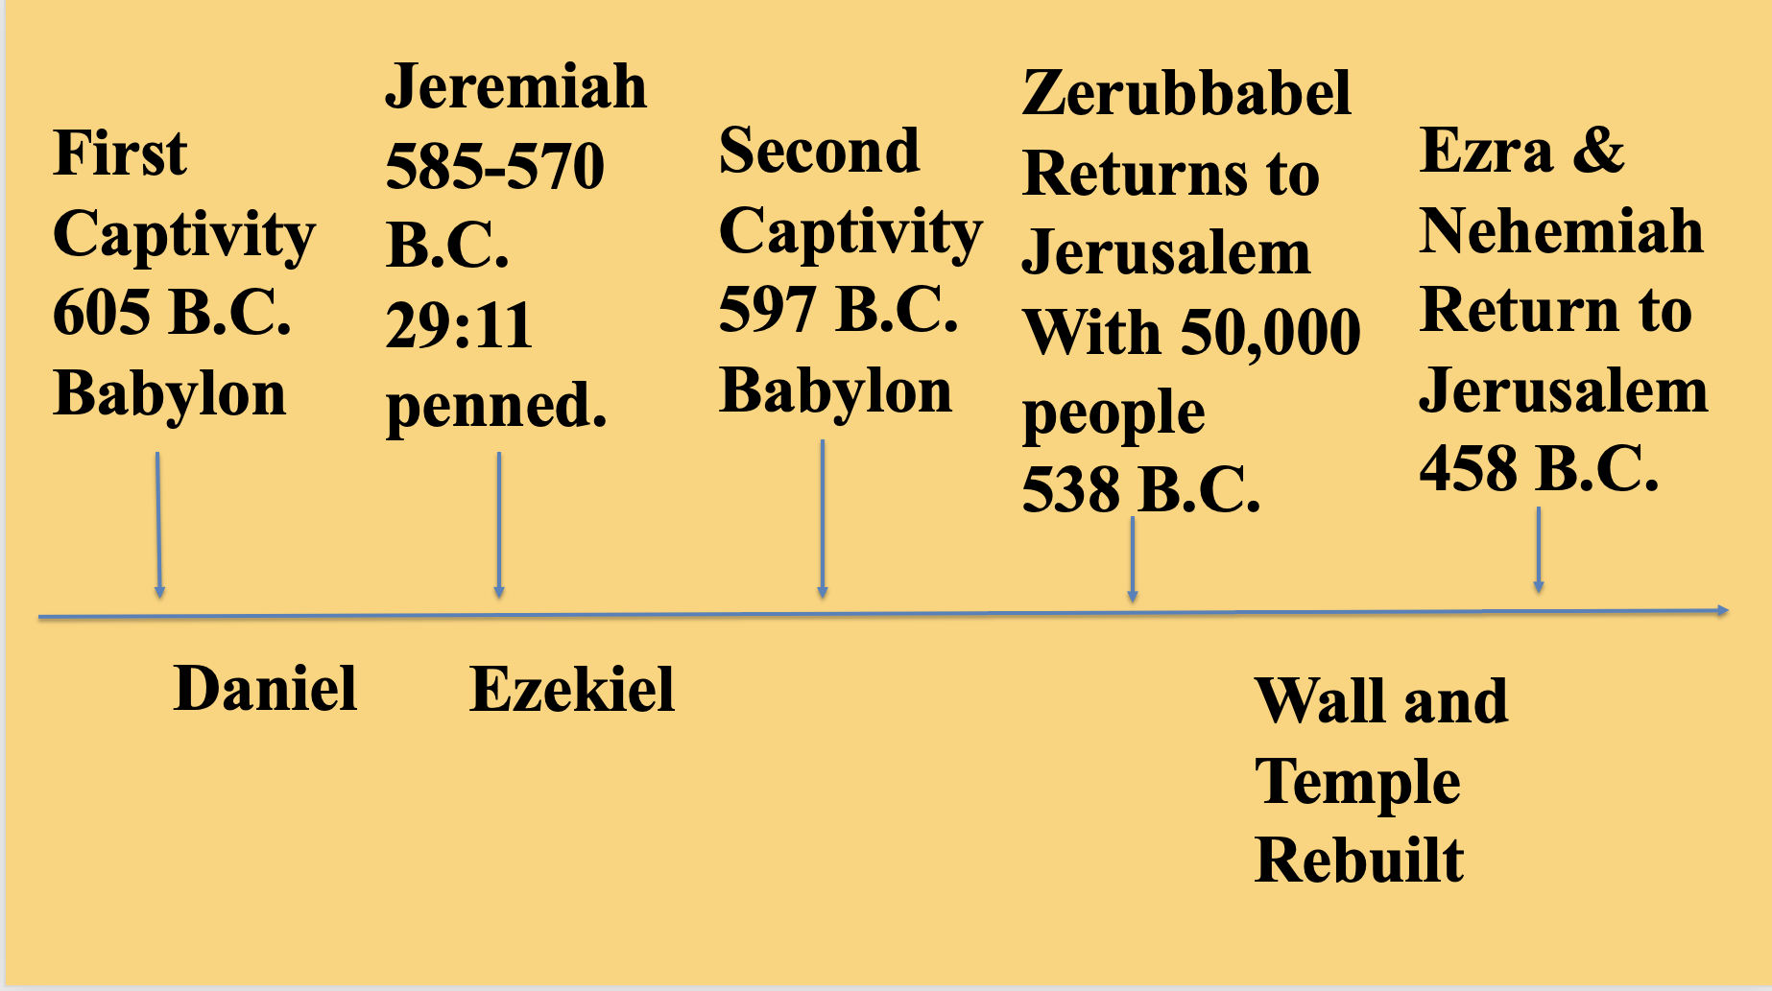
Jer. 29:10 “For thus says the LORD: When seventy years are completed for Babylon, I will visit you, and I will fulfill to you my promise and bring you back to this place. 11 For I know the plans I have for you, declares the LORD, plans for welfare and not for evil, to give you a future and a hope. 12 Then you will call upon me and come and pray to me, and I will hear you. 13 You will seek me and find me, when you seek me with all your heart. 14 I will be found by you, declares the LORD, and I will restore your fortunes and gather you from all the nations and all the places where I have driven you, declares the LORD, and I will bring you back to the place from which I sent you into exile.

So what is the historical context of this chapter? "Yes, Christians can lay claim to this verse, and they do because of Jesus Christ.” "The reason we claim it is because of the Last Supper. Remember Jesus lifted up the cup, which was his blood and he said 'this cup is the new covenant in my blood.'" Christ's crucifixion meant that the Old Testament promises would be fulfilled with those who come to faith in Jesus.
"Everything that God meant to be fulfilled for His people Israel now is going to be fulfilled in his people of the New Covenant.
So how does Jeremiah 29:11 properly apply to us (plural)? It applies to us collectively as we plug into the will of Jesus for the entire church in four specific ways:
WE NEED TO KNOW JESUS - JOHN 17:3
And this is eternal life, that they know you, the only true God, and Jesus Christ whom you have sent.
So What does it mean TO KNOW someone? It is beyond information to a heartfelt intimacy.

When we know JESUS we then have an “eternal perspective and we have a clear focus on life. “

WE NEED TO BE HIS MATURING DISCIPLES A believer who conforms ever fiber of their life, thinking, and behavior to be like Jesus and in response to Jesus.

WE NEED TO ACTIVELY MAKE DISCIPLES - Matthew 28:19-20
“Go therefore and make disciples of all nations….”

“Make disciples” is similar to the word “manufacture” because implies a process

What is the process, according to this verse in Matthew, when we build (make) a disciple?

First: Go and find potential disciples.
Second: Call Them to faith in Jesus.
Third: Train them into disciples.
Fourth: Send them out.

WE ARE TO LOVE AND CARE FOR ONE ANOTHER THROUGH THE CHURCH.

WHY? SO THAT THE EORLD TAKES NOTICE:

Tertullian
Here is what Tertullian wrote: “It is mainly the deeds of a love so noble that lead many to put a brand upon us. “See how they love one another”, they say, for they themselves are animated by mutual hatred; “how they are ready even to die for one another,” they say, for they themselves will sooner be put to death (The Apology, ch. 39).”
We often say: The Lord is in control. What does that mean to a cynical world? Virtually nothing until It means that His control is in us!

Our love, care, support, sacrifice, service to one another throughout our entire lives is His witness to the world that Jesus is Lord and Savior!

OUR ANSWER IS LIVING AND PROCLAIMING THAT WHETHER WE LIVE OR DIE, SUCCEED OR FAIL:
We will pursue Jesus to know Him.
We will continue to mature as his disciples even if others think we are foolish.
We will actively work to intentionally make disciples of others.
We will love and care for one another to such a depth that even our greatest adversaries will confess:
See how those Christians at St Paul’s love one another!

Pray This Word Into Your Life This Week:
Lord Jesus, give me your heart to truly loved you and to sacrificially love every member of St. Paul’s Lutheran Church. Empower this love to be genuine and practical so that the world around us will dramatically notice how much we love one another at St. Paul’s.

Lord energize my your heart, mind, soul and body for you and for one another. Instead of criticism empower me to bring answers. Instead of indifference empower me to get involved in the lives of others. Instead of fear grant me the power and courage to stand up for you and for my fellow believers.

