The Reality and Power of Faith
Luke 17:1-6. Rev. Thomas Parrish

Can faith grow? How can the church help?
17 And he said to his disciples, “Temptations to sin are sure to come, but woe to the one through whom they come! ² It would be better for him if a millstone were hung around his neck and he were cast into the sea than that he should cause one of these little ones to sin. ³ Pay attention to yourselves! If your brother sins, rebuke him, and if he repents, forgive him, ⁴ and if he sins against you seven times in the day, and turns to you seven times, saying, ‘I repent,’ you must forgive him.”
The Foundation for Jesus’ teaching on faith begins with vs. 1-2. Temptation is real, it is powerful, and most of us succumb to it one way or another.
Define biblical temptation: solicitation to that which is evil, and hence Satan is called "the tempter"
We can defeat temptation by: Honest confession. Accountability with a fellow Christian. Change your patterns.
DON’T BE A TEMPTER. Luke 17:1b but woe to the one through whom they come! ² It would be better for him if a millstone were hung around his neck and he were cast into the sea than that he should cause one of these little ones to sin.
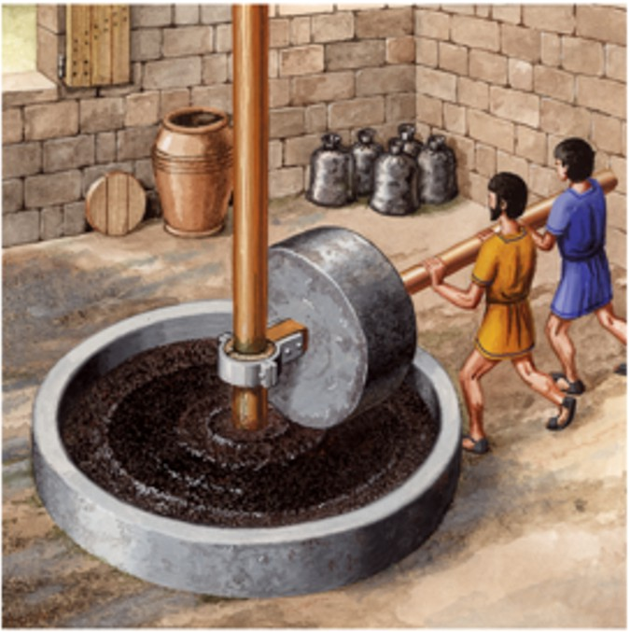
It’s bad enough to be tempted. It is much worse if you are the tempter. Evil is when you ignore Jesus and make your own rules for life. Wickedness is when you target another person and attempted to hurt, misguide or abuse them. Jesus says it would be better to have a millstone around your neck than to face judgement for tempting others. Average weight: 3300 lbs.
Jesus goes on and says: ³ Pay attention to yourselves! If your brother sins, rebuke him, and if he repents, forgive him, ⁴ and if he sins against you seven times in the day, and turns to you seven times, saying, ‘I repent,’ you must forgive him.”
It gets harder elsewhere in the bible: Matthew 18: ²¹ Then Peter came up and said to him, “Lord, how often will my brother sin against me, and I forgive him? As many as seven times?” ²² Jesus said to him, “I do not say to you seven times, but seventy-seven times.
These statements of Jesus, went way beyond what everyone thought forgiveness was about.
This is what prompts vs. 5 ⁵ The apostles said to the Lord, “Increase our faith!”
First we must clarify what faith is and is not! Jesus defines faith for us with the Mustard Seed Illustration. ⁶ And the Lord said, “If you had faith like a grain of mustard seed, you could say to this mulberry tree, ‘Be uprooted and planted in the sea,’ and it would obey you.
Biblical faith is always where you put (deposit) your trust. It is not based on my level of belief-it is based on WHO I BELIEVE IN! JESUS IS THE OBJECT OF FAITH (TRUST).
Can Faith Grow? How can the church help? Can the sacrifice and life, death and resurrection of Jesus grow? The answer is ________!
Clarify this truth: Ephesians 2:8-9 ⁸ For by grace you have been saved through faith. And this is not your own doing; it is the gift of God, ⁹ not a result of works, so that no one may boast.
The original language of the NT combines grace and faith as one item that is given to us as a GIFT.
Grace and Faith are like a full glass of water. How much more water can you add to a totally full glass? You can’t its already full.
You and I are 100% filled up with the grace and faith from Jesus already. So what’s the problem? Why do some seem to have more faith that others?
Two answers that we need to consider. Believers in Jesus desperately need one another to push us to do things we never even considered. Christians today are isolated!
The “One Another” passages in the NT are faith revealers. The church, you and me, need to be the Pacemakers, the pushers for one another. We need to be Cheering other believes to keep going, take risks, trust even when they don’t feel like it
WHY? SO THAT THE FAITH ALREADY WITHIN US IS PUSHED OUT IN THE CHALLENGES, THE PAINS, THE SUCCESSES OF LIFE.
We are called to push one another in love with toughness to let Jesus shine through us since he is fully within us.
This is why we, the leaders of St. Paul’s, have been led by Jesus to start HOUSE CHURCHES. The House Churches are one tool where we meet at least twice a month in a group of 10 to 12 people. You are urges to join a house church. Call Misrak at the church office (612-874-0133) and she will give you the possible house churches you can join.
Faith is always focused on Jesus.
As a gift he has given us all the faith we need.
Our responsibility it to let that faith emerge, take risks, do what seems impossible and trust Jesus for the outcome.

How much faith is needed? Mustard seed size because the object of that faith is Jesus the Messiah, King of Kings and Lord of Lords.

Prayer

